Connect the device’s AC adapter and mount the reed switch on a door. The PIR sensor needs to be set in a way, which will let it detect a cat, but not a human opening a door. Electrical tape can be used to limit the detection angle of the sensor. With the default settings, when a cat is detected waiting behind the door i.e. detected by the pir sensor and with the door closed (reed switch closed), an alarm is set off. The standard alarm is 3 repetitions of 3 led blinks combined with sound signals from the buzzer. After the alarm sequence, the led stays lit and the buzzer won’t be active during the following alarms. To turn off the led, and to activate the buzzing during alarms, the user needs to press the yellow button. The alarm sequence activation can be turned off by a sliding switch, but even in the off position, the detection is still active. This means that even though the user won’t hear or see an alarm, the led will be lit upon switching to the on position, signaling, that the cat was waiting behind the door, when the switch was in the off position.

EEPROM configuration memory

|  |  |  |  |
| --- | --- | --- | --- |
| address | size | variable | description |
| 0x00 | 1B | loudness | How loud will the buzzer buzz during the alarm sequence 0 = silent, 255 = loudest |
| 0x01 | 1B | repetition | How many times will the blinking and buzzing be repeated during the alarm sequence |
| 0x02 | 1B | Blinks in one repetition | How many times to blink and buzz in one repetition of the blinking sequence |
| 0x03 | 1B | Led after alarm | If the variable is equal to zero, the led will be turned off after an alarm, otherwise it will stay lit until the next blinking sequence, or reset. |
| 0x04 | 1B | Buzzer after alarm | If the variable is equal to zero, the buzzing will only take place during the first alarm. After a reset, the buzzing will be active once again. Will buzz every time if not equal to zero. |
| 0x05 | 1B | Load default configuration | It this variable is not equal to zero, the device will reset itself to the default configuration. |

The main unit of the device.

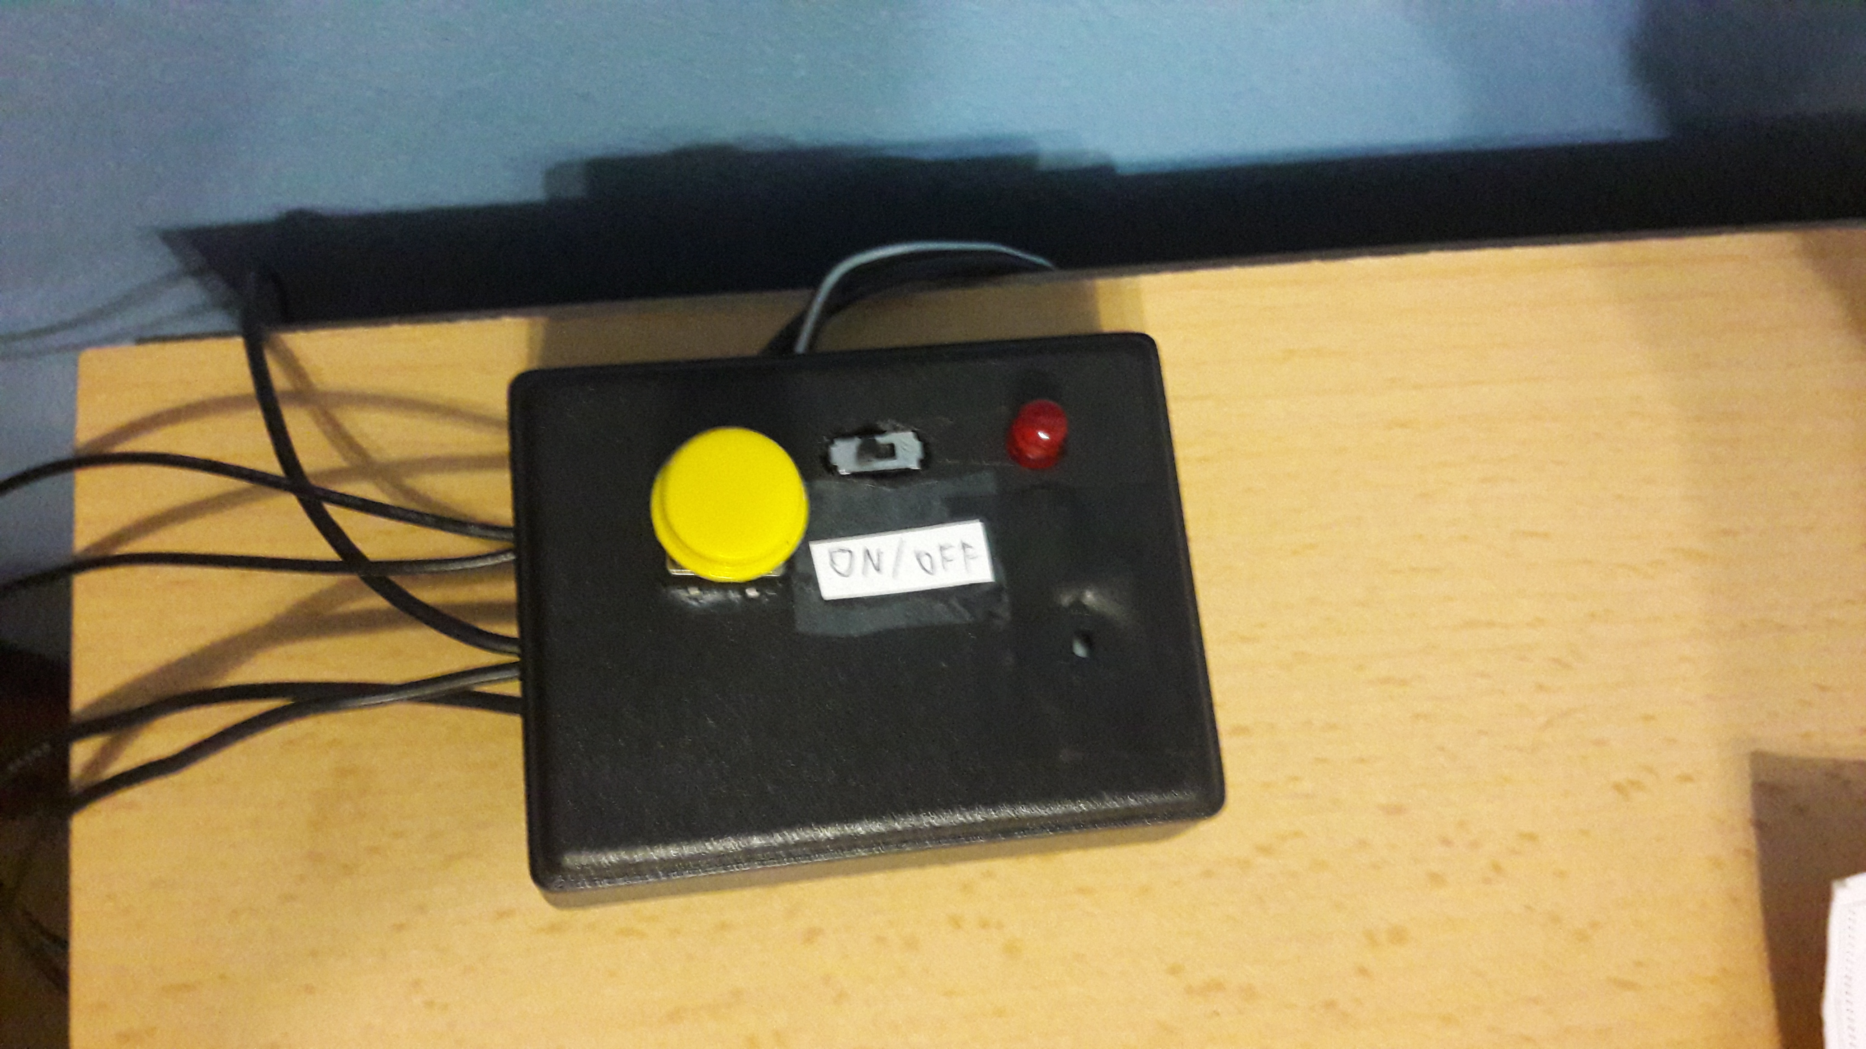

Closed door detector mounting.

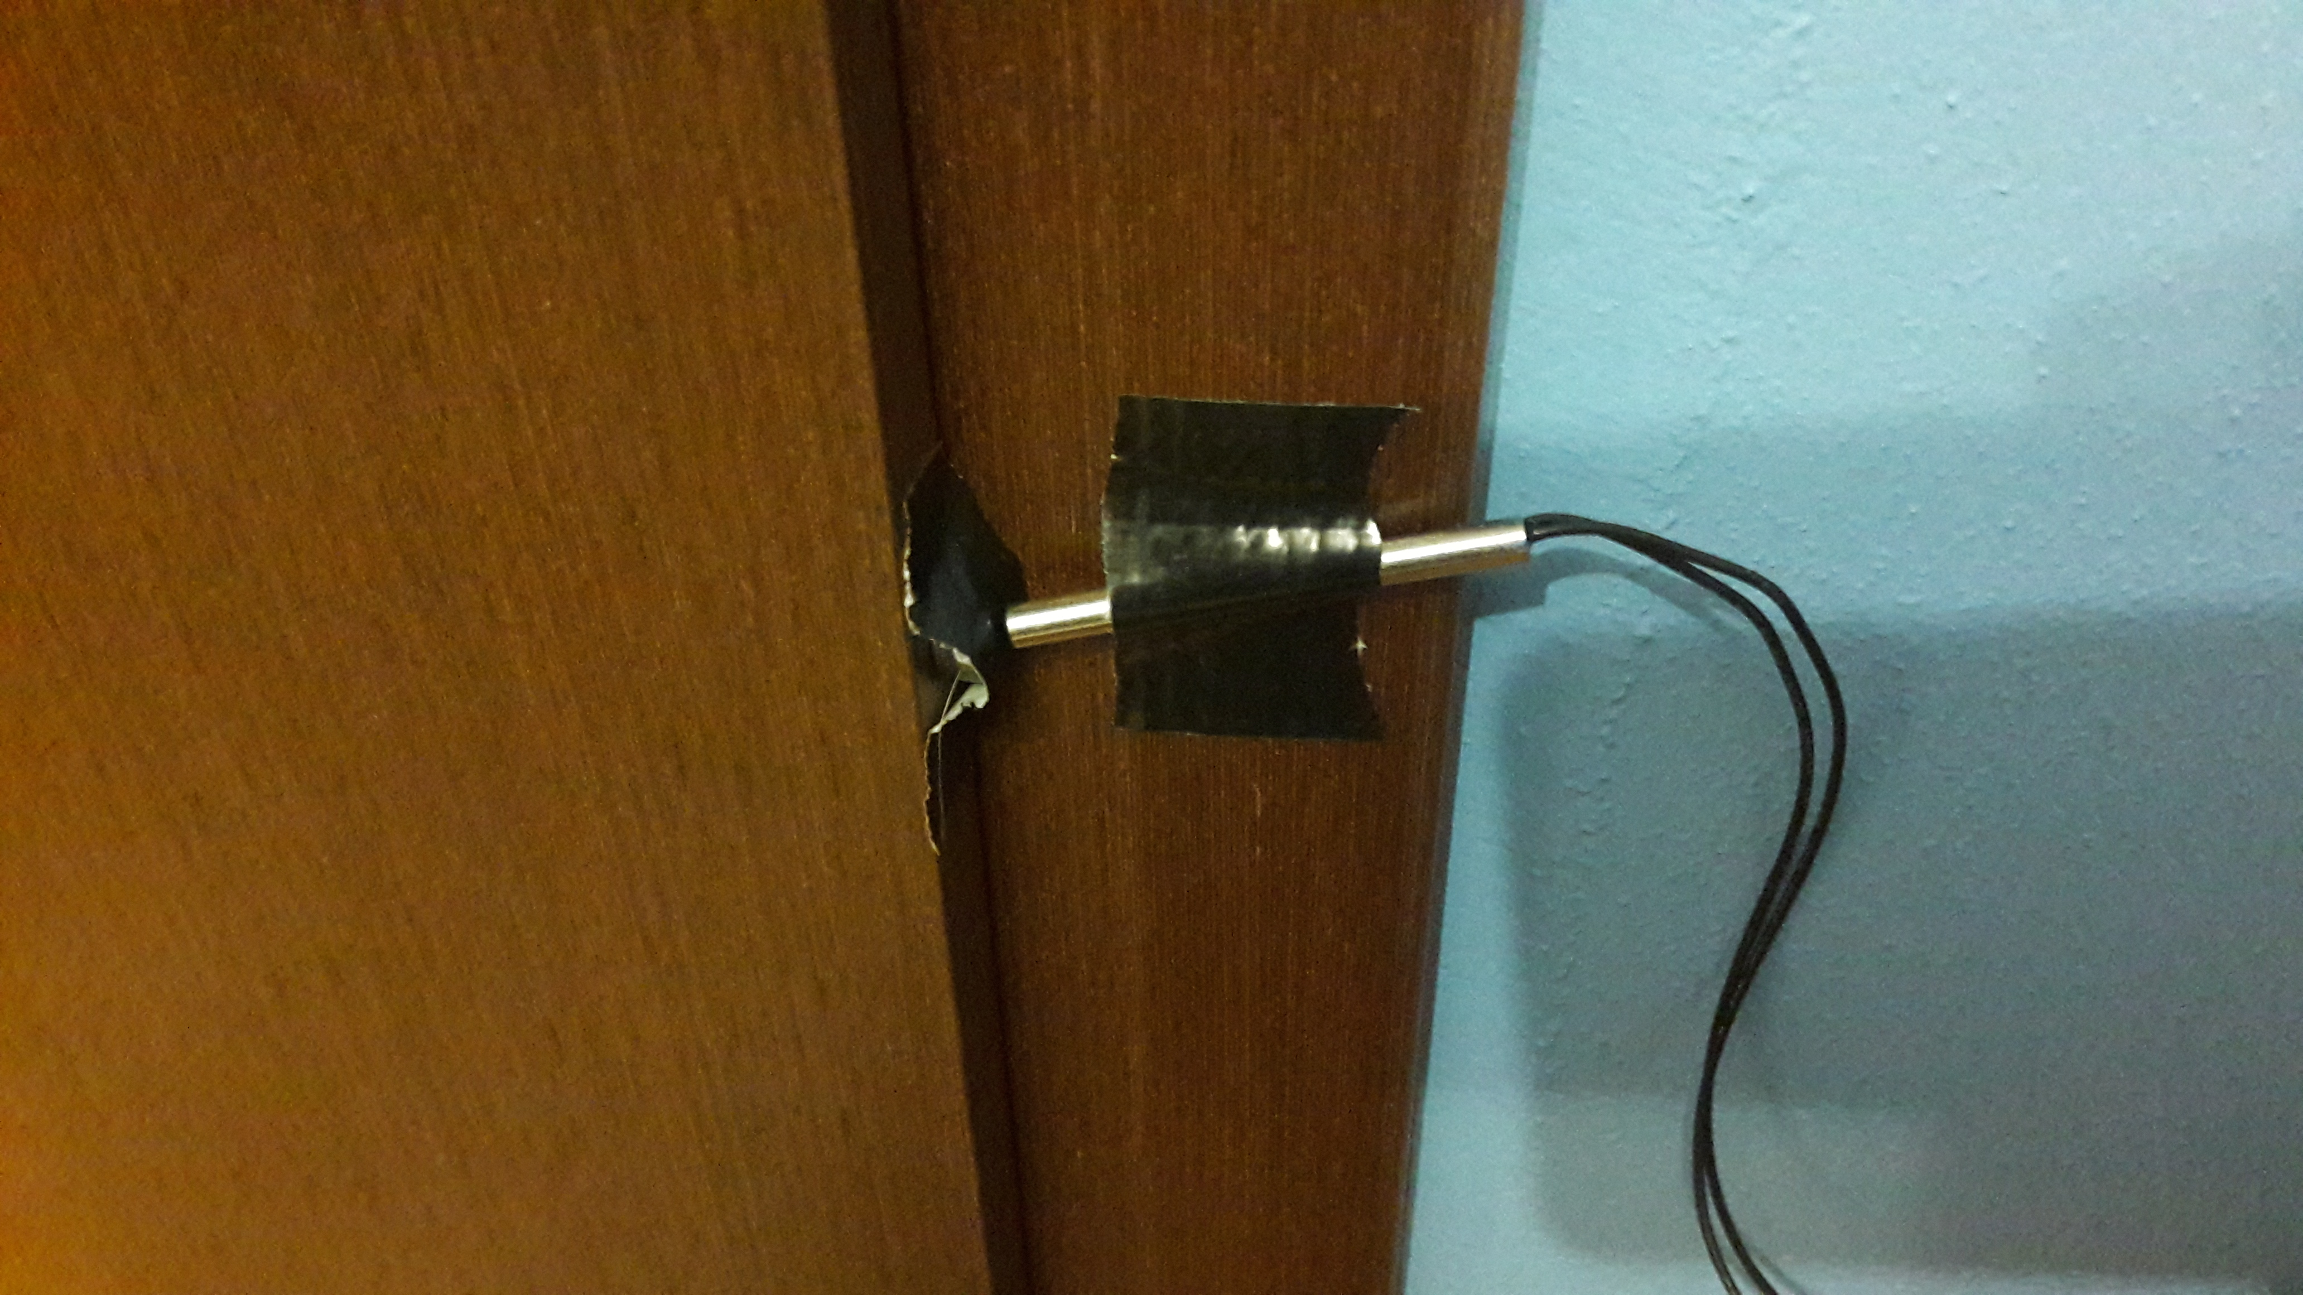

The device in the default configuration after an alarm.

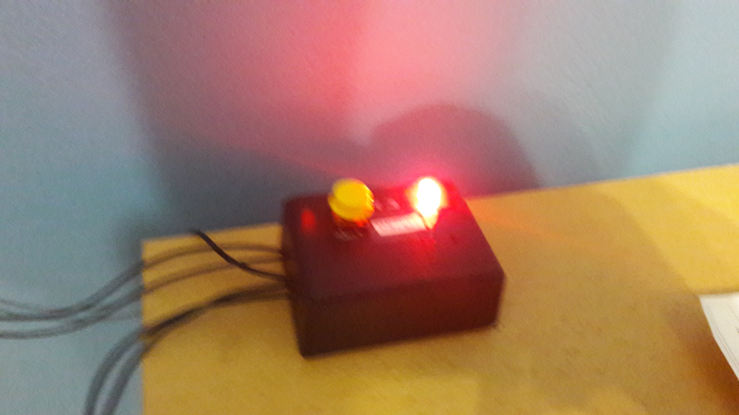

The PIR cat detector.

